Communication Systems

The **communication system** is a system which describes the information exchange between two points. The process of transmission and reception of information is called communication. The major elements of communication are the **Transmitter** of information, the **Channel or medium**of communication and the **Receiver** of information.

## Types of Communication Systems

Depending on signal specification or technology, the communication system is classified as follows:

**(1) Analogue**

Analogue technology communicates data as electronic signals of varying frequency or amplitude. Broadcast and telephone transmission are common examples of analogue technology.

**(2) Digital**

In digital technology, the data are generated and processed in two states: High (represented as 1) and low (represented as 0). Digital technology stores and transmits data in the form of 1s and 0s.

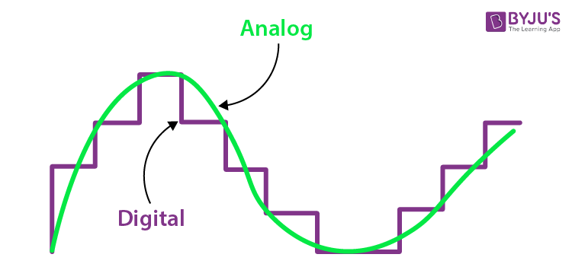

Depending on the communication channel, the communication system is categorised as follows:

**1. Wired** (Line communication)

* Parallel wire communication
* Twisted wire communication
* Coaxial cable communication
* Optical fibre communication

**2. Wireless** (Space communication)

* Ground wave communication
* Skywave communication
* Space wave communication
* Satellite communication

## Examples of Communication Systems

The following are a few examples of communication systems:

1. Internet

2. Public Switched Telephone Network

3. Intranet and Extranet

4. Television

## Elements of Communication Systems

The definitions of the terms used in the communication system are discussed below.

**Information**

Message or information is the entity that is to be transmitted. It can be in the form of audio, video, temperature, picture, pressure, etc.

**Signal**

The single-valued function of time carries the information. The information is converted into an electrical form for transmission.

**Transducer**

It is a device or an arrangement that converts one form of energy to the other. An electrical transducer converts physical variables such as pressure, force, and temperature into corresponding electrical signal variations. For example, a microphone converts audio signals into electrical signals. The photodetector converts light signals into electrical signals.

**Amplifier**

The electronic circuit or device that increases the amplitude or the strength of the transmitted signal is called an amplifier. When the signal strength becomes less than the required value, amplification can be done anywhere between the transmitter and receiver. A DC power source will be provided for the amplification.

**Modulator**

As the original message signal cannot be transmitted over a large distance because of their low frequency and amplitude, they are superimposed with high frequency and amplitude waves called carrier waves. This phenomenon of superimposing of message signals with a carrier wave is called modulation, and the resultant wave is a modulated wave which is to be transmitted.

There are different types of modulation, and they are explained below:

i. Amplitude Modulation (AM)

The process of changing the amplitude of the signal wave by impressing or superimposing it on a high-frequency carrier wave, keeping its frequency constant, is called amplitude modulation.

ii. Frequency Modulation (FM)

Frequency modulation is a technique in which the frequency of the message signal is varied by modulating with a carrier wave. It is better than amplitude modulation because it eliminates noise from various sources.

iii. Phase Modulation (PM)

The phase of the carrier wave changes the phase of the signal wave. The phase shift after modulation is dependent on the frequency of the carrier wave as well. Phase modulated waves are immune to noise to a greater extent.

**Transmitter**

It is the arrangement that processes the message signal into a suitable form for transmission and, subsequently, reception.

**Antenna**

An antenna is a structure or a device that will radiate and receive electromagnetic waves. So, they are used in both transmitters and receivers. An antenna is basically a metallic object, often a collection of wires. The electromagnetic waves are polarised according to the position of the antenna.

**Channel**

A channel refers to a physical medium such as wire, cables, or space through which the signal is passed from the transmitter to the receiver. There are many channel impairments that affect channel performance to a pronounced level. Noise, attenuation and distortion, to mention the major impairments.

**Noise**

Noise is one of the channel imperfections or impairments in the received signal at the destination. There are external and internal sources that cause noise. External sources include interference, i.e. interference from nearby transmitted signals (cross talk), interference generated by a natural source such as lightning, solar or cosmic radiation, automobile-generated radiation, etc. The external noise can be minimised and eliminated by the appropriate design of the channel and shielding of cables. Also, by digital transmission, external noise can be minimised.

Internal sources include noise due to random motion and collision of electrons in the conductors and thermal noise due to diffusion and recombination of charge carriers in other electronic devices. Internal noise can be minimised by cooling and using digital technology for transmission.

⎫ A different cable design.

⎫ Proper design of the channel.

⎫ Use digital transmission

⎫ Using BPF or LPF at the receiver side.

#### Learn More:

* [Pulse Width Modulation](https://byjus.com/physics/pulse-width-modulation/)

**Attenuation**

Attenuation is a problem caused by the medium. When the signal is propagating for a longer distance through a medium, depending on the length of the medium, the initial power decreases. The loss in initial power is directly proportional to the length of the medium. Using amplifiers, the signal power is strengthened or amplified so as to reduce attenuation. Also, digital signals are comparatively less prone to attenuation than analogue signals.

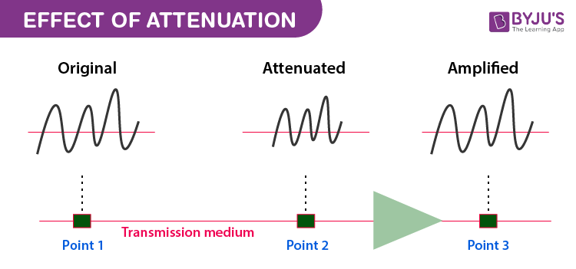

**Distortion**

It is also another type of channel problem. When the signal is distorted, the distorted signal may have a frequency and bandwidth different from the transmitted signal. The variation in the signal frequency can be linear or non-linear.

**Receiver**

An arrangement that extracts the message or information from the transmitted signal at the output end of the channel and reproduces it in a suitable form as the original message signal is a receiver.

**Demodulator**

It is the inverse phenomenon of modulation, i.e., the process of separation of the message signal from the carrier wave takes place in the demodulator. The information is retrieved from the modulated wave.

**Repeaters**

Repeaters are placed at different locations in between the transmitter and receiver. A repeater receives the transmitted signal, amplifies it and sends it to the next repeater without distorting the original signal.

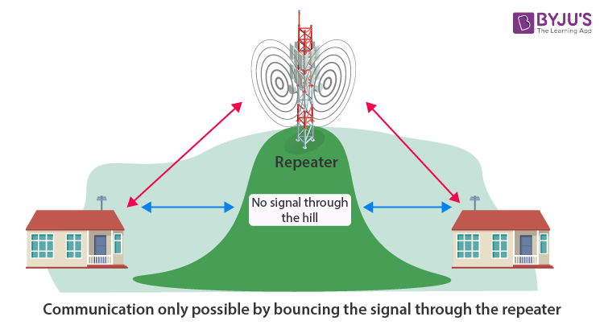

## Block Diagram of Communication Systems

The block diagram given below represents the flow of the signal from the source to the destination. The role of every device and arrangement discussed above will help to understand better.

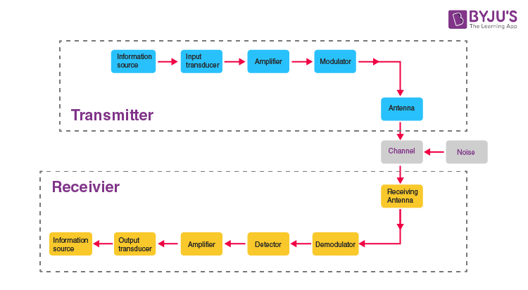

## **Objective Questions**

**1. Which of the following is not an essential element of a communication system?**

a) Transmitter b) Transducer

c) Receiver d) Communication Channel

**2. A device which provides output in electrical form or it has input in electrical form is called a ____.**

a) Transmitter b) Receiver

c) Repeater d) Transducer

**3. Decrease in signal strength due to energy losses is called _____.**

a) Distortion b) Interference

c) Attenuation d) Noise

**4. The disturbance or distortion in the transmission and processing of message signals is called ______.**

a) Noise b) Attenuation

c) Interference d) None of these

**5. A repeater is a combination of _____.**

a) Receiver b) Amplifier

c) Transmitter d) All of these

**Answers**

1. d

2. d

3. c

4. a

5. b

## Frequently Asked Questions on Communication Systems

Q1

### What are the elements of a communication system?

Information Source

Input Transducer

Transmitter

Channel

Receiver

Output Transducer

Q2

### What are the types of modulation?

Amplitude Modulation

Frequency Modulation

Phase Modulation

Q3

### What are the types of communication systems?

Based on the technology, the communication system is classified as analogue and digital. Based on the communication channel, the communication system is categorised as wired and wireless.